x
Issue 82 – July 2020
SPECIAL VOICES NEWSLETTER
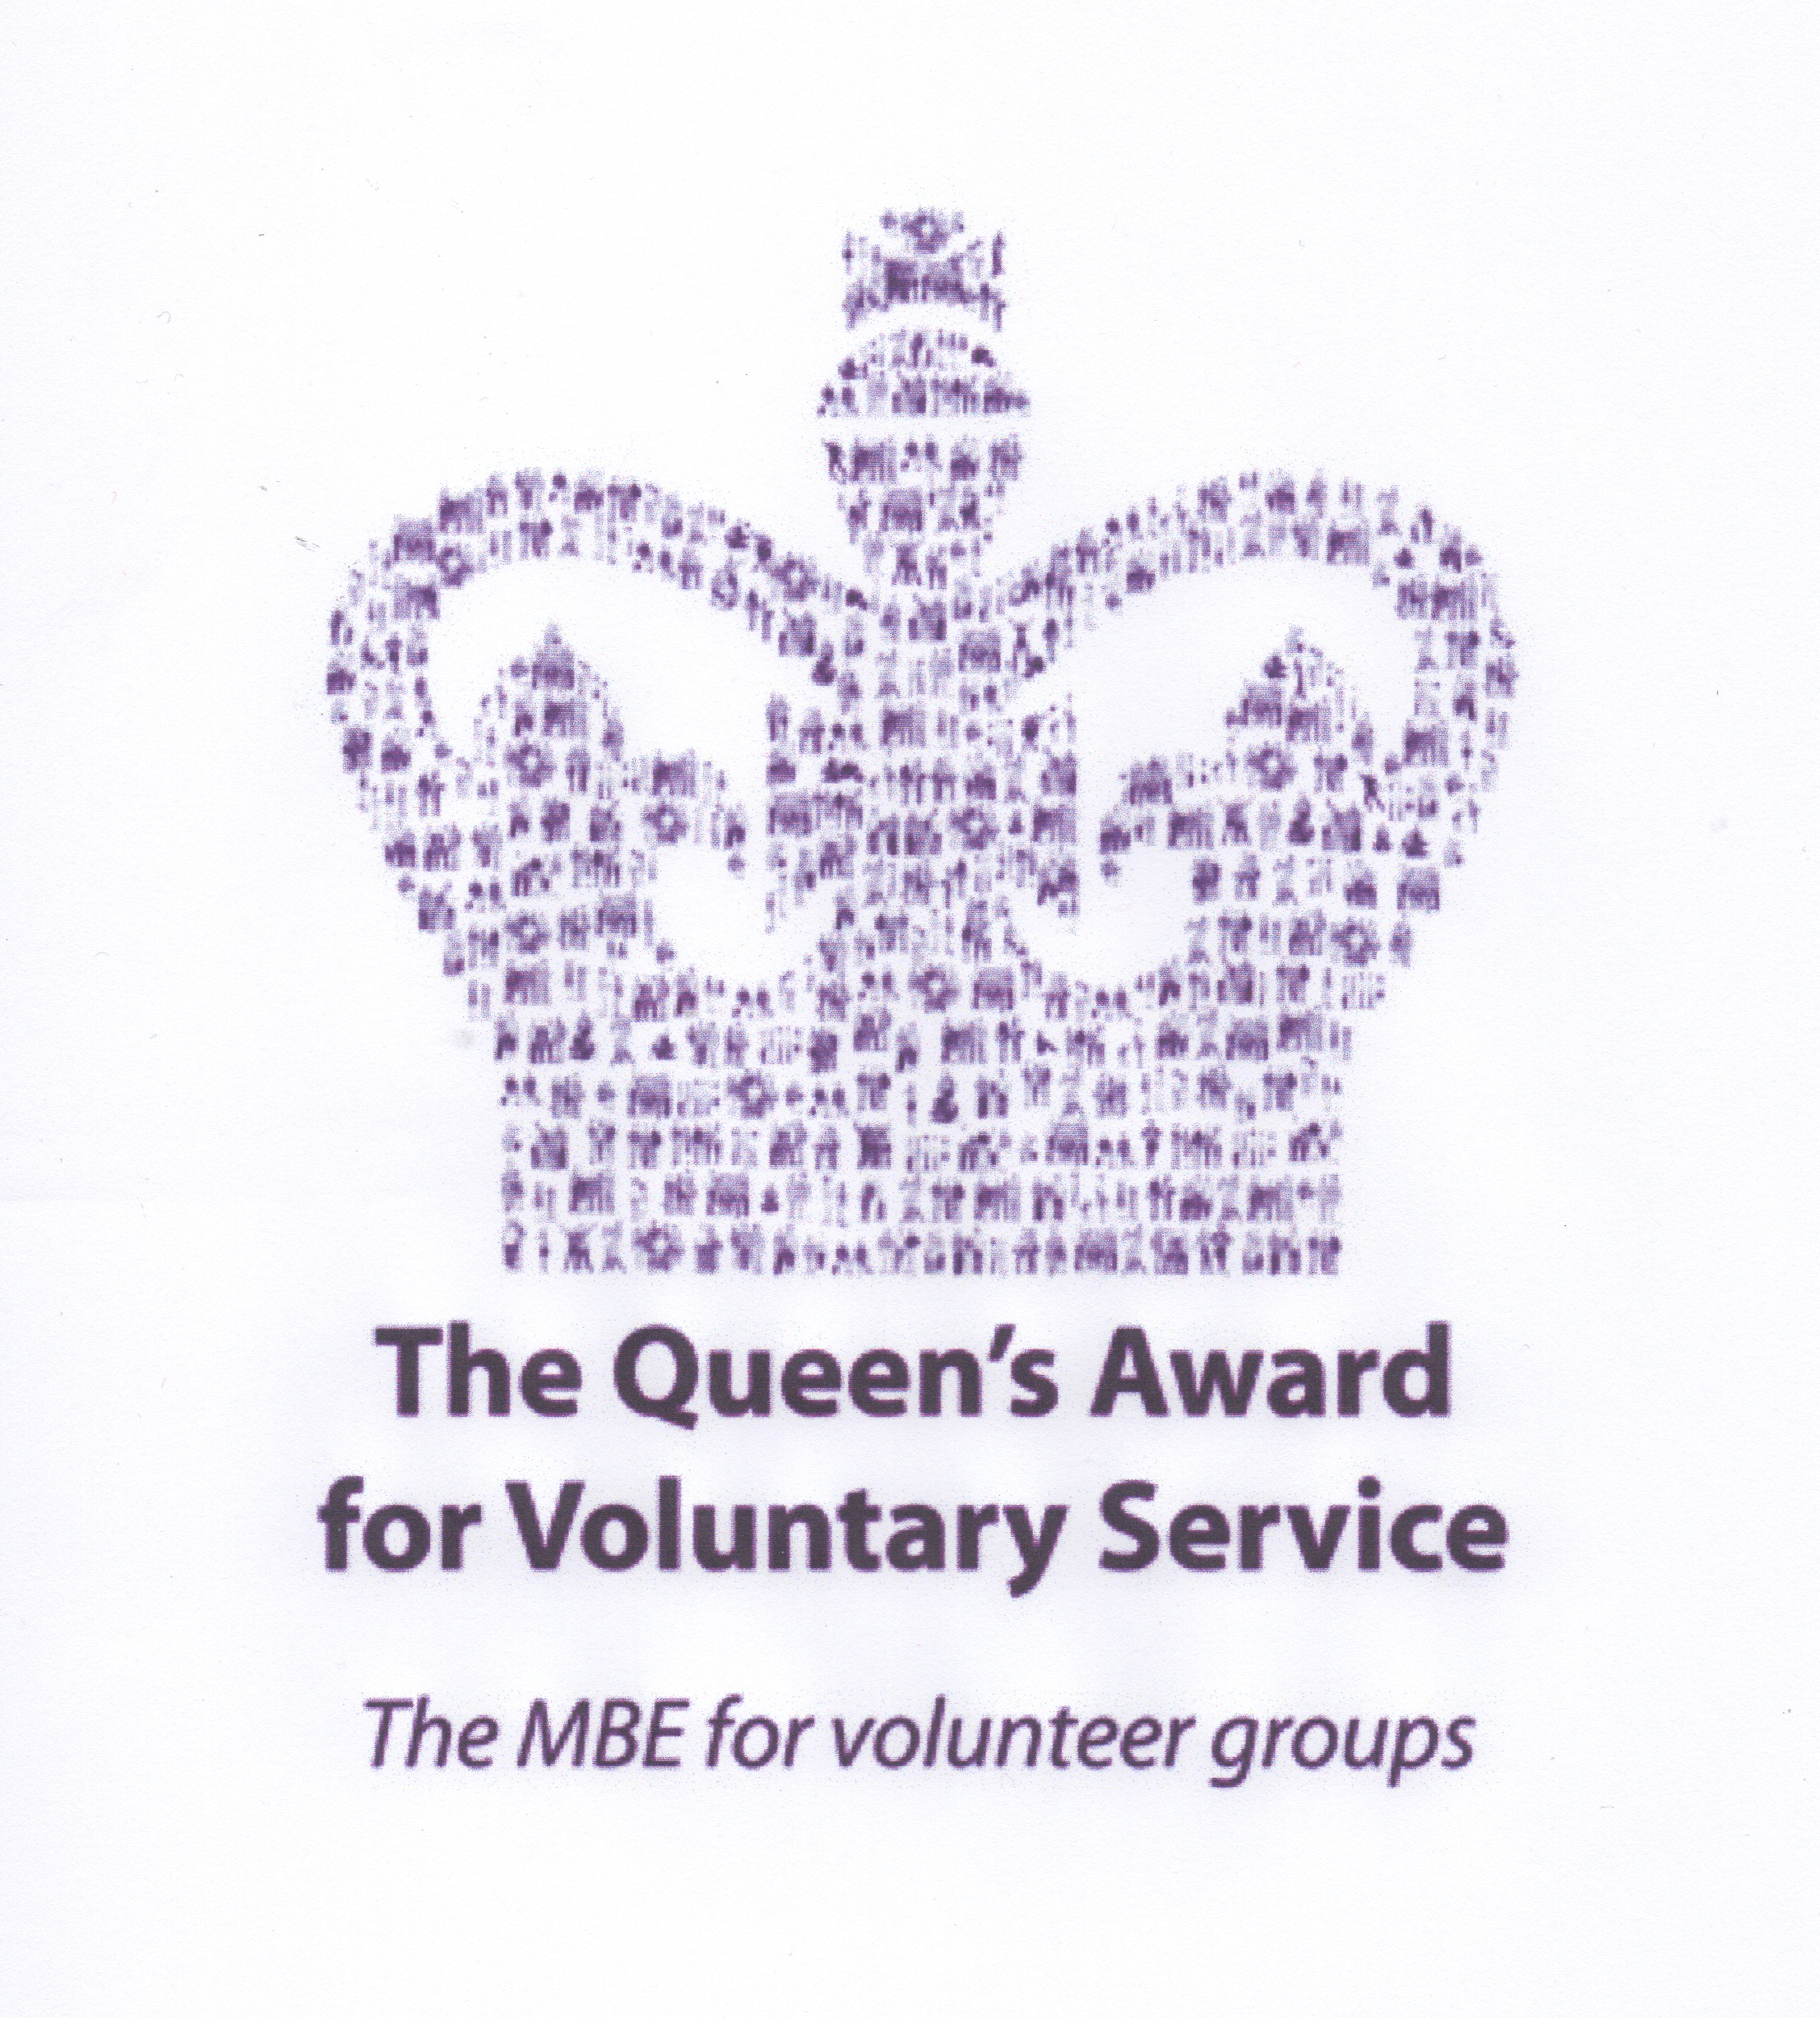
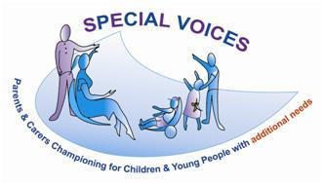

Welcome to Special Voices (Slough parent/carer forum)
Special Voices is a group of parent/carers of children, young people & adults with disabilities/additional needs & is the parent/carer forum for Slough. We are all volunteers working in partnership with the Slough Children’s Services Trust, Local Authority, CCG’s and voluntary organisations to help shape and develop future services in Slough through participation and co-production with all your views & experiences that you share with us, without you we couldn’t change things for all children/young people/adults in Slough.
needs children/young people & adults.

CONTACT US:
Tel: 07990 693439
07487 524361
07956 368421
info@specialvoices.co.uk
“Like” us on Facebook
Special Voices Community Group
Donate to us: localgiving.org/charity/specialvoices
Follow us on:
Twitter @specialvoices

www.specialvoices.co.uk

Classroom 3,
Cippenham Baptist Church. 11 Elmshott Lane. SL1 5QS
Our office is closed during Covid – 19 but will open again soon with an appointment system in place, social distancing means we are changing the layout to include screens for when it is safe for us all to return:

Hi all
We at Special Voices, like the majority of you have found social distancing, isolation & lockdown a massive challenge as parent/carers. This last month we have seen some easing of the lock down with the provision that it is up to all of us to keep with social distancing as this is a way of preventing the spread of the virus even with the distance being lowered now so we are told. We are seeing some positive signs, like shops, zoos, attractions, football, schools, pubs & bars open again. It is all very different but together we can get used to this just like all NHS staff & supermarket staff had to get used to it from day one, they adapted immediately, so can we. There are some people that can now come out of shielding & there are some that can’t for the time being & it’s up to all of us to continue making sure they have everything they need within our circles. There are some children/young people in school & some that aren’t for now but that is changing with more & more going back as the Prime Minister said he wants all children & young people back in September. Information in the news that it will be compulsory along with the mention of fines for parents that don’t send children back but don’t let this alarm you as there are people you can talk to if you are unsure of just what to do for the best, just call us so we can let you know who can answer your questions.
We at Special Voices know that for some it has been a difficult decision whether or not to send children back to school & the worry of keeping them safe, naturally everyone wants all children & school staff to remain safe at all times that is why there are risk assessments & guidance in place.
We know the challenges carers face every day with an additional need’s child/young person or adult to care for without adding home schooling into the mix plus no respite at all from it 24/7 for some, we may have different circumstances but we are all in this together. It is a positive step forward for our children/young people to return to school where we are confident that all schools will be following the government guidelines on how this should be done to keep everyone safe. We are here to listen even if you just want to talk about nothing in particular, we have added two more telephone numbers.
Please don’t feel alone, just talk to us, or someone else there is help available, together we can get through this

Come and

Please try and make this event as iwill barers in order to plan any trips or outings for the cared for

Virtual Coffee Days, Every Friday between 2 - 4pm with ZOOM
We now have to manage our “coffee days” in a different way while social distancing is in place & do hope you will join us virtually with Zoom
Every Friday “Drop” in anytime between 2 – 4pm, you can choose at what time, & how long you wish to join us for during the two hours & we look forward to seeing you.
Friday 3rd July, topic – Have you been contacted about your child’s return to school in September or contacted about a short break during the school holidays, please let us know
We have chosen Zoom as we believe it is quite easy to set up & free should you need help to do this then please give us a call on: 07990693439 beforehand
Each week you join us your name will be entered into a draw for a free small gift as a thank you for your continued support.

WE NEED YOUR HELP! we have some surveys that need to be completed so we are telephoning you using the numbers overleaf & do hope you can do this with us. If you have a spare 10 minutes & want to help to do this then text us & we will call you back to complete it
New to Special Voices? We are still taking contact details for you to join us in all that we do as we need your feedback & experiences on services here in Slough

This year Special Voices hosted activities with Zoom during Carers Week & our theme for the week was: Every Carer Matters” because you do to us.
We held, quick draw Competition - Fancy dress/ hat/ best clothes
Bingo – How to arrange a vase/bunch of flowers like the experts & ending the week with our Coffee Day and “fetch me” game all our activities had prizes (49)
A massive thank you to Squirrels Health Foods in Burnham High Street for supporting carers during these difficult times by donating our 50th prize which was a huge basket of fresh fruit, it had all kinds of fruit including a pineapple for one lucky winner
Thank you to Courtney for her flower arranging skills during the session & so we could all do it again she provided us with written step-by-step instructions

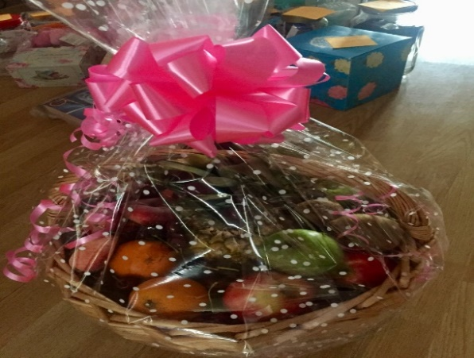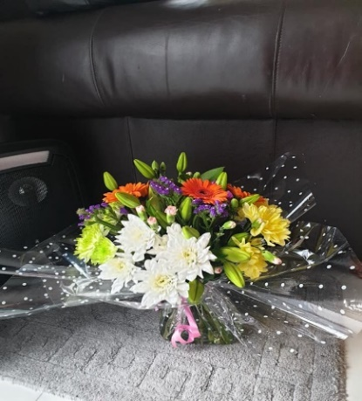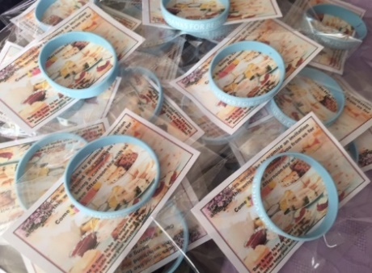

We also gave out wristbands as a thank you to carers with the promise of an afternoon tea with lots of cake, scones, jam & cream when it is safe to do so & we can all meet again, together. Contact us for a carer’s wrist band

Declaimer: Please note that inclusion of information in this Newsletter does not imply endorsement of products or services by Special Voices. Information correct at time of print

